**Documentation of the Project:**

1. **Data Acquisition:** The project involved receiving data in CSV format, each category separated into different files such as city, competitor_event, event, games, games_city, games_competitor, medal, noc_region, person, person_region and sport Additionally, the data was provided in SQL format. Initially, the CSV files were uploaded into a SQL database, and data extraction was performed based on specific queries.
2. **Excel Visualization:** After uploading the data into the SQL database, it was exported to Excel. Visualizations were then created in Excel based on the extracted data.
3. **Integration with Power BI:** Furthermore, the SQL database was connected to Power BI. Data transformation was carried out according to specific queries, and key performance indicators (KPIs) and metrics were computed. An overview of the visuals was provided to efficiently extract insights from the data.

This documentation outlines the process of importing data from CSV files to SQL, creating Excel visuals, connecting the SQL database to Power BI, and deriving insights through visualization and data analysis.

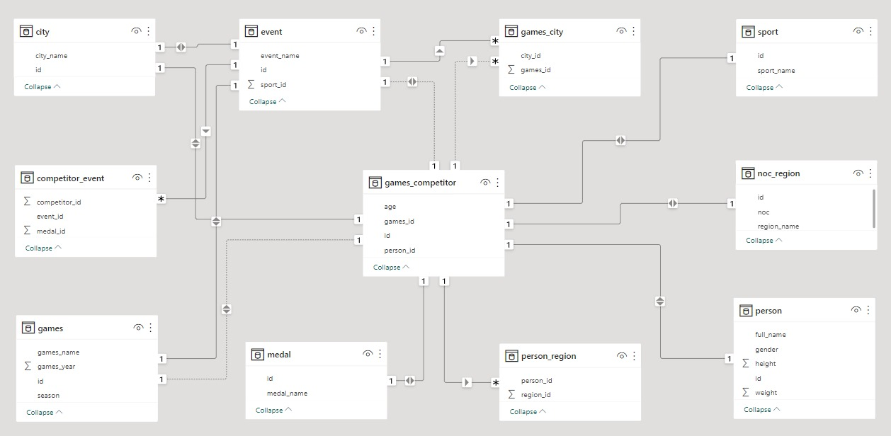

**Olympic Sport History :**.

In the vast landscape of sports analysis, understanding its historical evolution provides invaluable insights into its present-day significance and future potential. This capstone project aims to embark on a captivating journey through the annals of time, tracing the rich history of sports analysis from its humble beginnings to its current prominence. By exploring key milestones, pioneering methodologies, and revolutionary advancements, we seek to unravel the intricate tapestry of sports analysis and its profound impact on the world of sports.

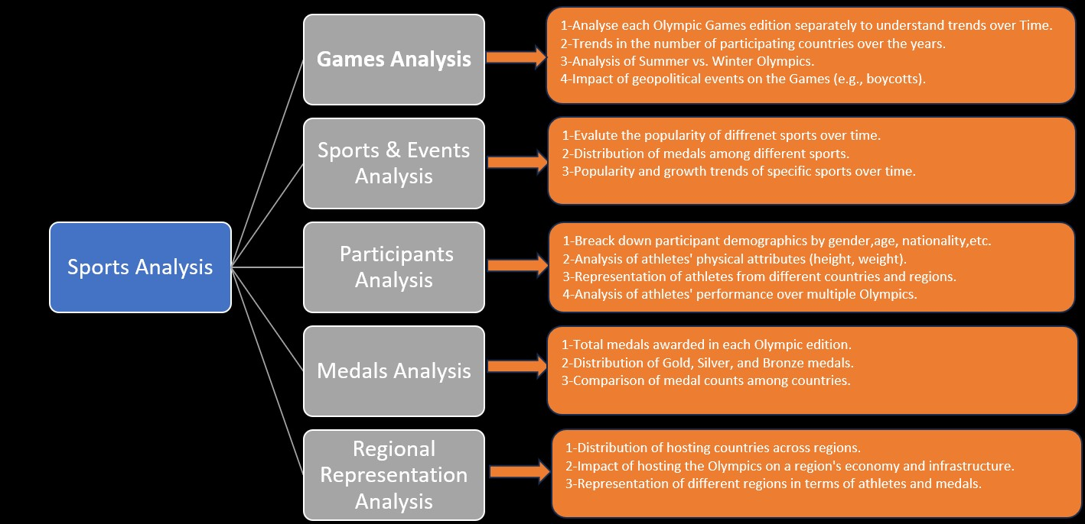

**Conclusion:-**

The Capstone Project on Olympic Sports Analysis demonstrates the application of SQL and Power BI in extracting, analyzing, and visualizing complex sports data. By uncovering insights and trends, this project provides valuable information for stakeholders and enthusiasts, contributing to a deeper understanding of Olympic sports dynamics.

This documentation serves as a comprehensive guide to the Olympic Sports Analysis Capstone Project, detailing the methodology, findings, and potential avenues for future exploration.